# CS 340 README Template

*Use this template to complete your README file. When completing the template, keep the headings as they are so that your document has a clear organization. Remove the italicized prompt text after you have completed each section for a polished final document.*

**Describe the required functionality:**

The required functionality of this Project is to showcase the Grazioso Salvare information and to showcase a software application that will be able to work with existing data from the animal shelter. In the pictures I listed, you can see their functionalities and how you can see the differences between the other animals through a pie chart. Added in the logo for Grazioso and my name into the Project as a unique identifier.

**Describe the tools used to achieve this functionality and a rationale for why these tools were used:**

MongoDB was the main component of the development; the server being linked to the program helped exponentially since it gave the code all the information through the database. It’s efficient when interacting with Python. The Dash framework provides a view and controller structure for the web application because it displays the animals' names along with their information and showcases them on the map as well for the person to view. Not only that, but the person can view a pie chart showing a comparison between the two animals.

**Explain the steps that were taken to complete the project:**

The steps that were taken to complete this project all started back in module six, I first began by setting up the map which was hard at first to figure out as a whole and include the filtered table with information of the database. I struggled at first in Module Six to link my information on the database, although I ended up figuring it out and connected the Mongo DB server to the program. Afterwards, I began to work on the graph chart, which was the key difficult problem I had with this assignment. I then focused on the buttons to filter the types of dogs through Water Rescue, Mountain or Wilderness Rescue, Disaster or Indvidual Tracking, and Reset as an option to turn everything back to its normal state.

**Identify any challenges that were encountered and explain how those challenges were overcome:**

The challenge that I experienced was just making sure that the buttons were all attached to the right places in the code, I was having some difficulty trying to figure out how to exactly make the pie chart and I felt as though it was the most difficult part of this entire Project. I basically had to look up on the resources and figure it out, especially after running into what was a block in the wall with the chart where I messed it up completely although I managed to pull through and figure it out altogether in the end and even separate the animals into different categories this way you can click on the chart and actually compare the types of animals.

### Screenshots



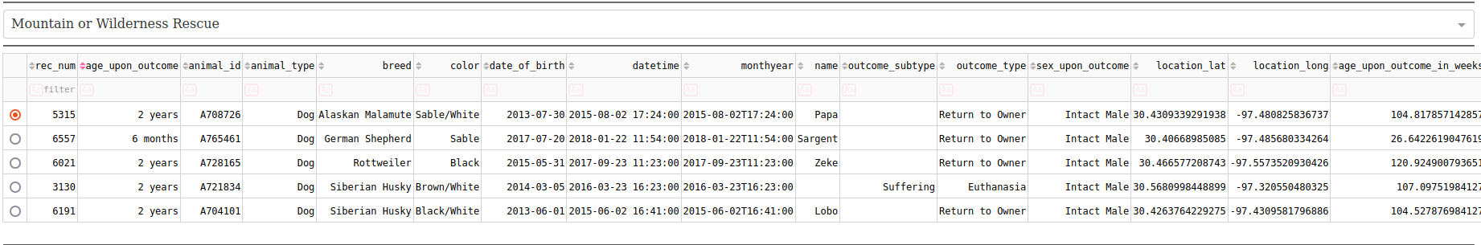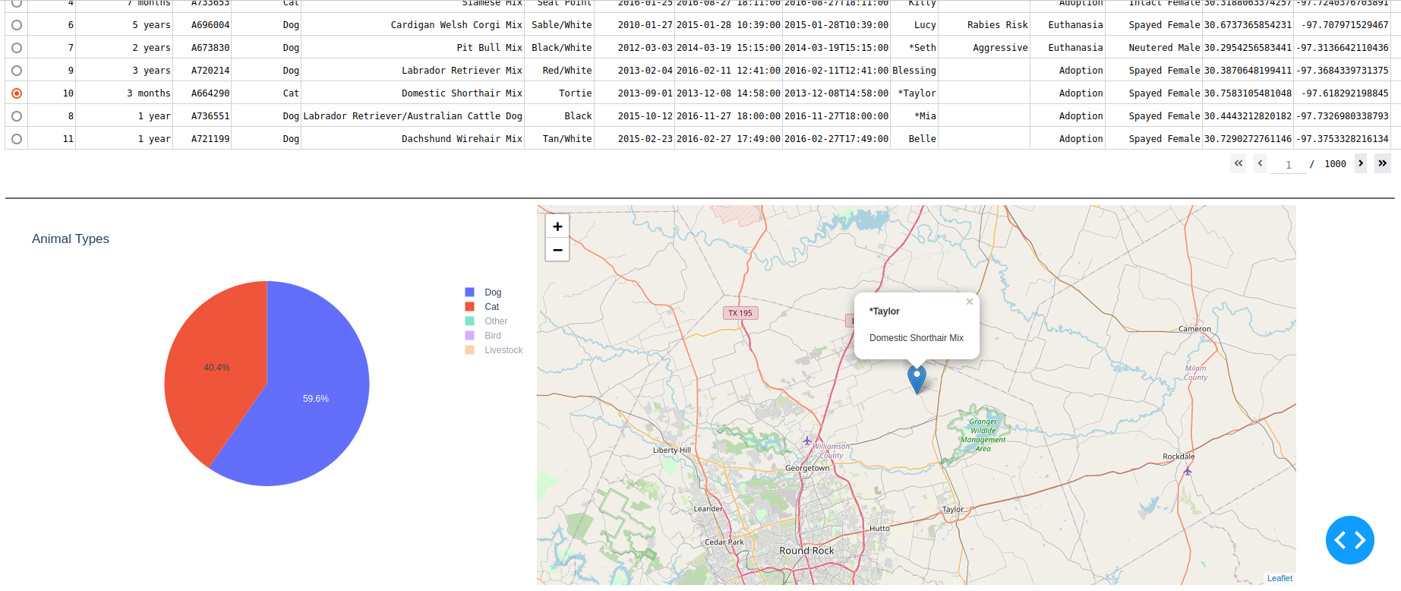

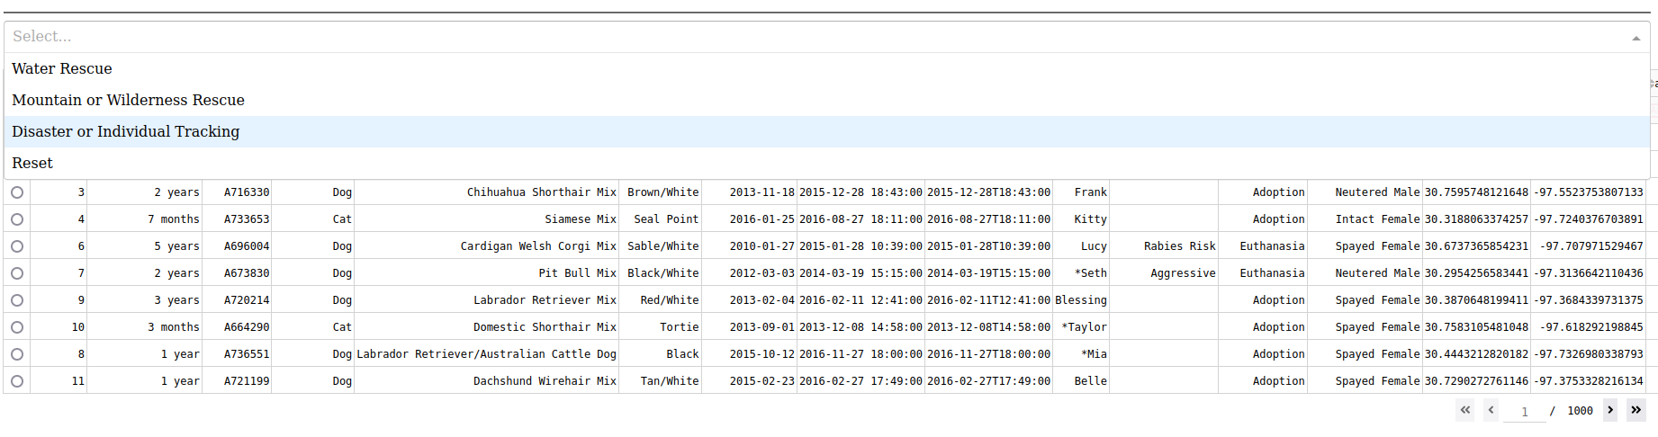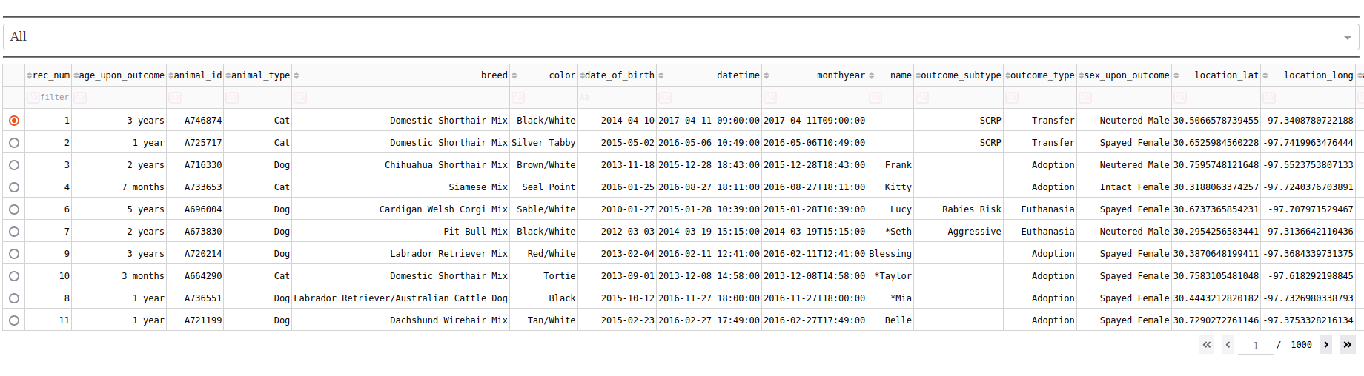

## Contact

Your name: Janncy Mota